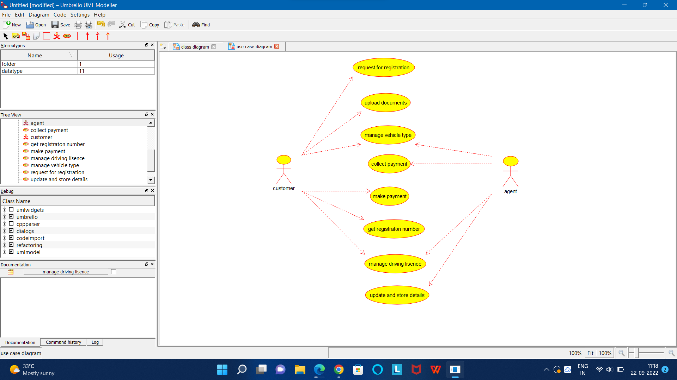

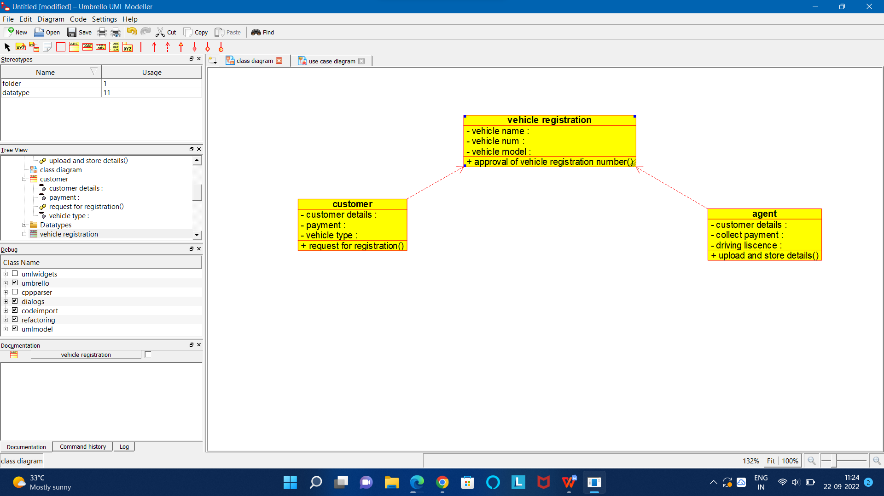

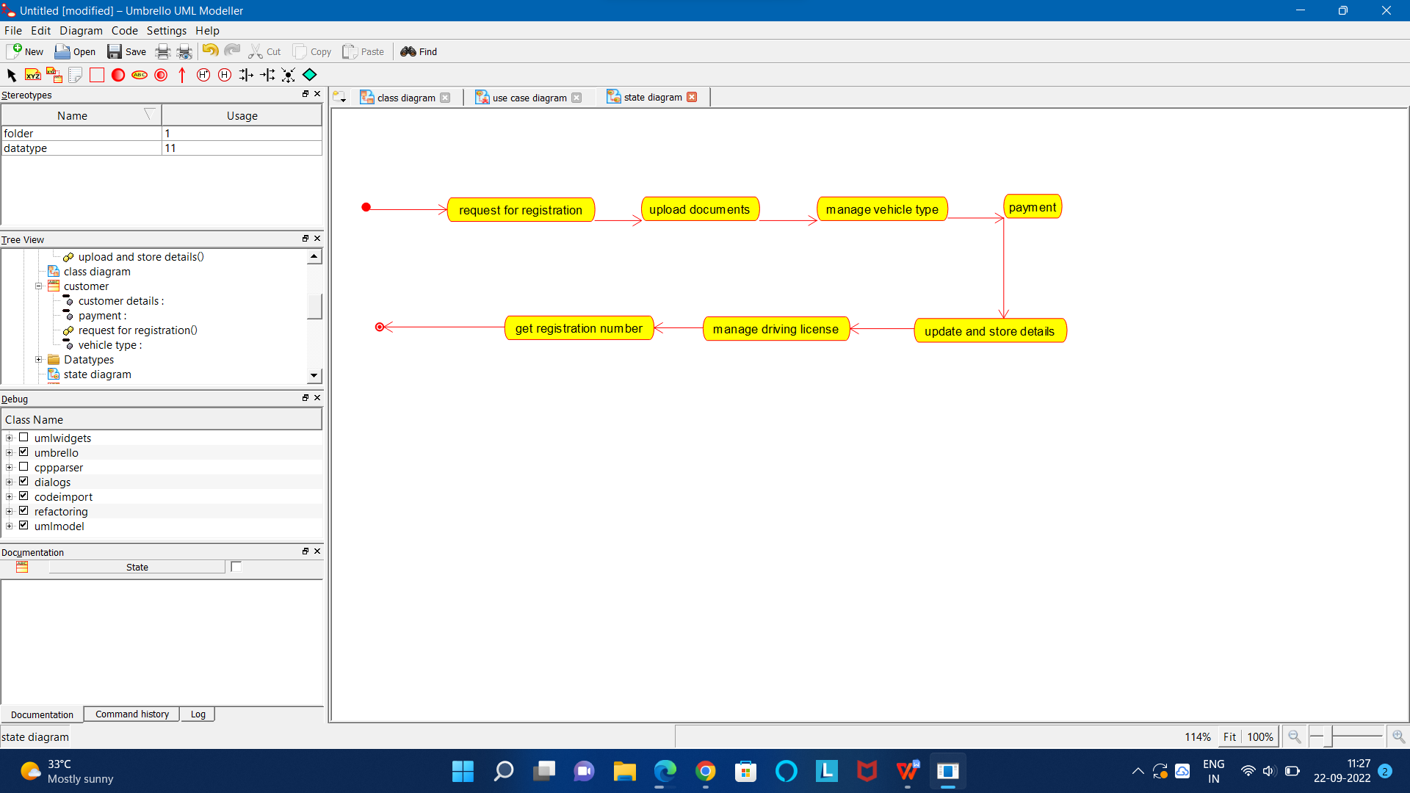

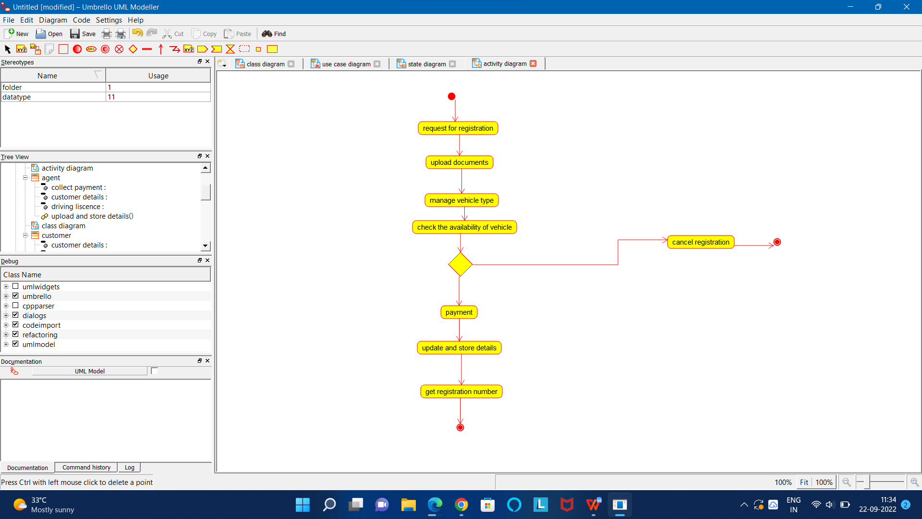

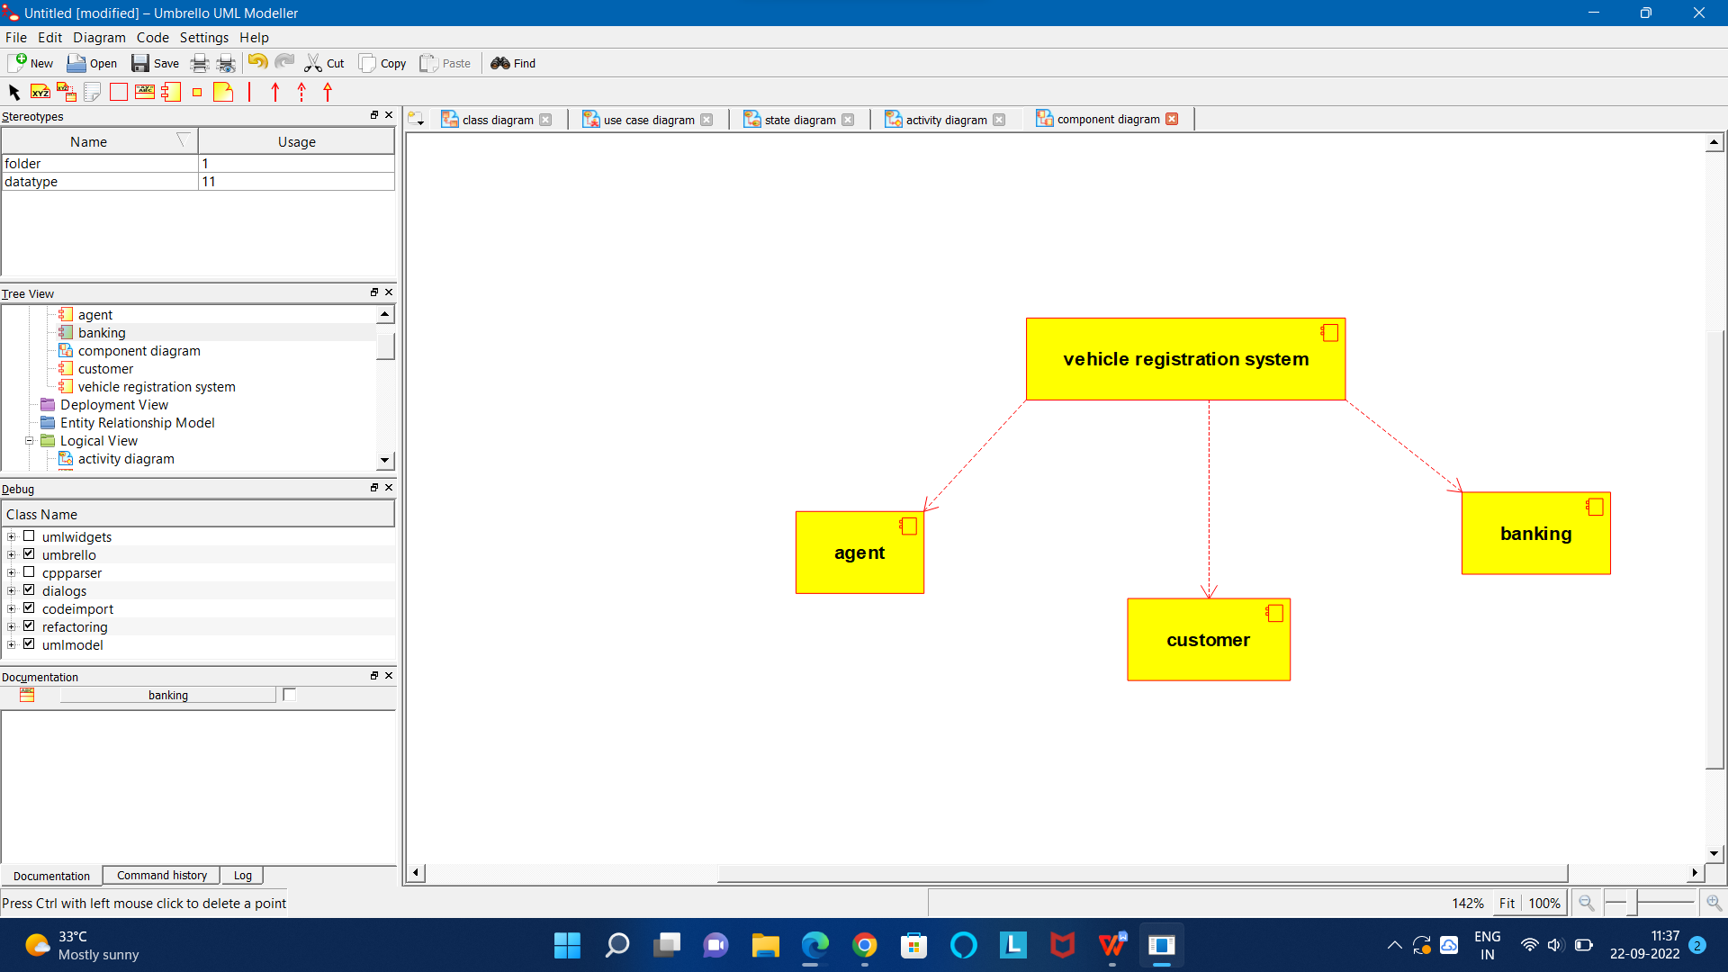

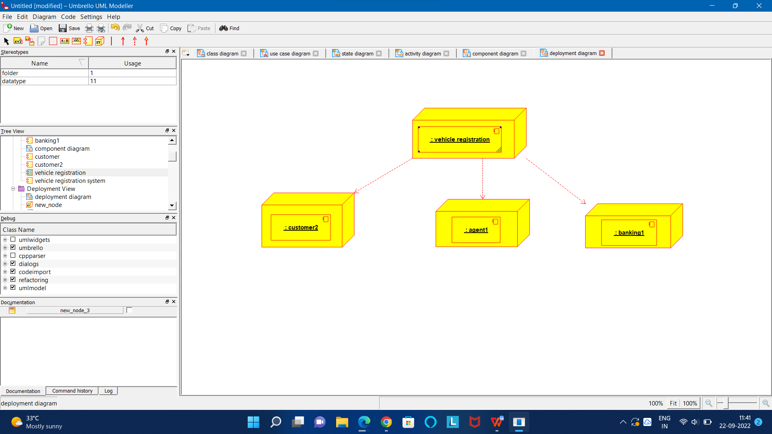

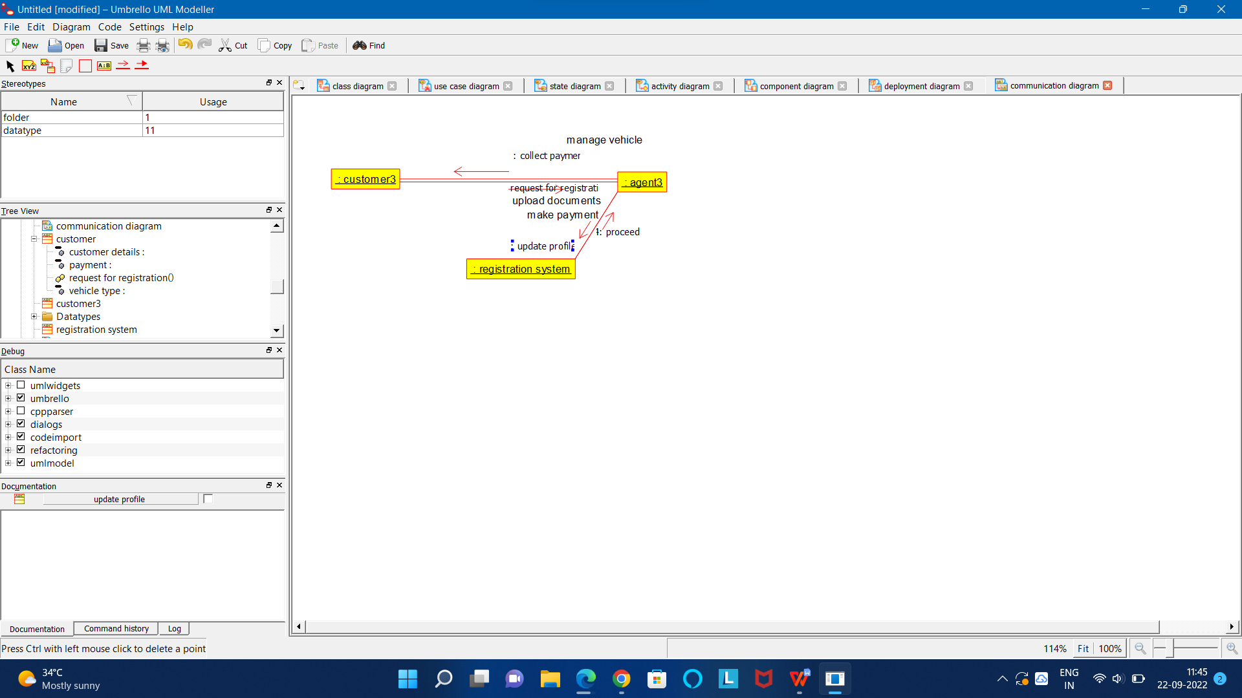

CODE FOR AGENT:

/**

* Class agent

*/

public class agent {

//

// Fields

//

private void customer_details;

private void collect_payment;

private void driving_liscence;

//

// Constructors

//

public agent () { };

//

// Methods

//

//

// Accessor methods

//

/**

* Set the value of customer_details

* @param newVar the new value of customer_details

*/

private void setCustomer_details (void newVar) {

customer_details = newVar;

}

/**

* Get the value of customer_details

* @return the value of customer_details

*/

private void getCustomer_details () {

return customer_details;

}

/**

* Set the value of collect_payment

* @param newVar the new value of collect_payment

*/

private void setCollect_payment (void newVar) {

collect_payment = newVar;

}

/**

* Get the value of collect_payment

* @return the value of collect_payment

*/

private void getCollect_payment () {

return collect_payment;

}

/**

* Set the value of driving_liscence

* @param newVar the new value of driving_liscence

*/

private void setDriving_liscence (void newVar) {

driving_liscence = newVar;

}

/**

* Get the value of driving_liscence

* @return the value of driving_liscence

*/

private void getDriving_liscence () {

return driving_liscence;

}

//

// Other methods

//

/**

*/

public void upload_and_store_details()

{

}

}

CODE FOR AGENT3:

/**

* Class agent3

*/

public class agent3 {

//

// Fields

//

//

// Constructors

//

public agent3 () { };

//

// Methods

//

//

// Accessor methods

//

//

// Other methods

//

}

CODE FOR VEHICLE REGISTRATION:

/**

* Class vehicle_registration

*/

public class vehicle_registration {

//

// Fields

//

private void vehicle_name;

private void vehicle_num;

private void vehicle_model;

//

// Constructors

//

public vehicle_registration () { };

//

// Methods

//

//

// Accessor methods

//

/**

* Set the value of vehicle_name

* @param newVar the new value of vehicle_name

*/

private void setVehicle_name (void newVar) {

vehicle_name = newVar;

}

/**

* Get the value of vehicle_name

* @return the value of vehicle_name

*/

private void getVehicle_name () {

return vehicle_name;

}

/**

* Set the value of vehicle_num

* @param newVar the new value of vehicle_num

*/

private void setVehicle_num (void newVar) {

vehicle_num = newVar;

}

/**

* Get the value of vehicle_num

* @return the value of vehicle_num

*/

private void getVehicle_num () {

return vehicle_num;

}

/**

* Set the value of vehicle_model

* @param newVar the new value of vehicle_model

*/

private void setVehicle_model (void newVar) {

vehicle_model = newVar;

}

/**

* Get the value of vehicle_model

* @return the value of vehicle_model

*/

private void getVehicle_model () {

return vehicle_model;

}

//

// Other methods

//

/**

*/

public void approval_of_vehicle_registration_number()

{

}

}

CODE FOR REGISTRATION SYSTEM:

/**

* Class registration_system

*/

public class registration_system {

//

// Fields

//

//

// Constructors

//

public registration_system () { };

//

// Methods

//

//

// Accessor methods

//

//

// Other methods

//

}

CODE FOR CUSTOMER:

/**

* Class customer

*/

public class customer {

//

// Fields

//

private void customer_details;

private void payment;

private void vehicle_type;

//

// Constructors

//

public customer () { };

//

// Methods

//

//

// Accessor methods

//

/**

* Set the value of customer_details

* @param newVar the new value of customer_details

*/

private void setCustomer_details (void newVar) {

customer_details = newVar;

}

/**

* Get the value of customer_details

* @return the value of customer_details

*/

private void getCustomer_details () {

return customer_details;

}

/**

* Set the value of payment

* @param newVar the new value of payment

*/

private void setPayment (void newVar) {

payment = newVar;

}

/**

* Get the value of payment

* @return the value of payment

*/

private void getPayment () {

return payment;

}

/**

* Set the value of vehicle_type

* @param newVar the new value of vehicle_type

*/

private void setVehicle_type (void newVar) {

vehicle_type = newVar;

}

/**

* Get the value of vehicle_type

* @return the value of vehicle_type

*/

private void getVehicle_type () {

return vehicle_type;

}

//

// Other methods

//

/**

*/

public void request_for_registration()

{

}

}

CODE FOR CUSTOMER3:

/**

* Class customer3

*/

public class customer3 {

//

// Fields

//

//

// Constructors

//

public customer3 () { };

//

// Methods

//

//

// Accessor methods

//

//

// Other methods

//

}